HACKUP TECHNOLOGY PVT.LTD

INTERNSHIP : AI – POWERED SOC & DIGITAL FORENSICS
WEEK – 1 : PROJECT 2 REPORT

BY :
P. AKSHAYA (24202)
B.SC.CS (SSS)

LOG INVESTIGATION

PROJECT TITLE :
(Analyze provided log files to identify failed login attempts and suspicious activity)

LOG INVESTIGATION :
Log investigation means checking a computer’s activity records is called logs , and to find problems, malicious activities, or cyberattacks.
For example : Think of logs like a CCTV recording for a computer system. They automatically keep track of everything happens inside of a system.

IMPORTANCE OF LOG INVESTIGATION IN CYBERSECURITY
Log investigation is important because it helps companies and organizations keep their computers / networks safe . systems are automatically save the records of malicious activities . security teams check the logs to find dangerous activities.

Log investigation helpful for ,
- To Find hackers or cyber threats
- Watch users malicious activities
- Detect attacks early
- Investigate a security problems
- Improve system security
[ Real time example : when a hacker tries many times enter into a company account using wrong passwords. The system saves all these attempts in the logs.A security team checks the logs, notices the different activity, and understands that someone may be trying to hack the account. The team can then block the attacker and protect the system. ]

INTRODUCTION

checking Linux log files to find suspicious activities, failed login attempts, and security.This was done using Kali Linux and the log files were collected from the /var/log folder, where Linux systems store activity records.
- Check and analyze system log files
- Find failed login attempts
- Detect suspicious SSH login activities
- Learn how to use Linux commands for log investigation
- Understand how Linux records authentication and security events

TOOLS REQUIRED
Kali linux
Terminal
SSH
LOG DIRECTORY:
The /var/log directory in Linux is the central storage location for logs. Logs are records generated by operating system and applications to keep track the errors, user activity, and system services .
Important log file identified :
auth.log | Authentication and login activity
dpkg.log | Package installation and update history
journal/ | Systemd journal logs
kern.log | Kernel-related events and messages
cron.log | Scheduled task (cron job) activity
boot.log | System boot process events

STEPS :

1.Changing into the Log Directory
Command - cd /var/log
- cd = Change Directory
- /var/log = The directory where Linux stores log files
This command moves the terminal from current location into a system log directory.

2. Listing Files in the Directory :
Command - ls (This command displays the names of files and folders inside the current directory.)
3. Listing Detailed Information
Command - ls -la
In this command is shows about a log directories .
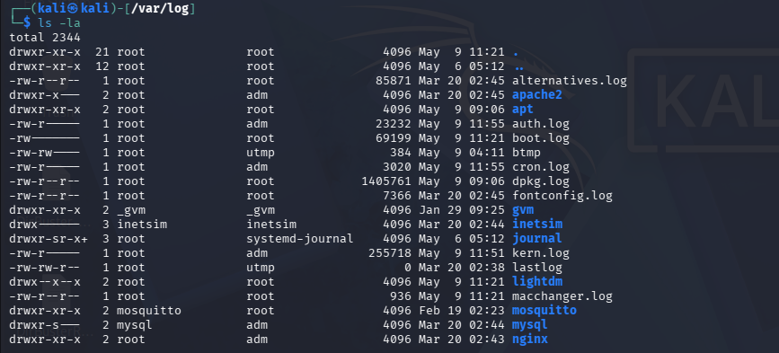

4. dpkg.log Investigation
Command - sudo cat /var/log/dpkg.log
the dpkg.log file maintains detail records of package management activity on the Linux system.
The log showed evidences like ;
- Package installation
- Software configuration
- System upgrades
- Package status changes
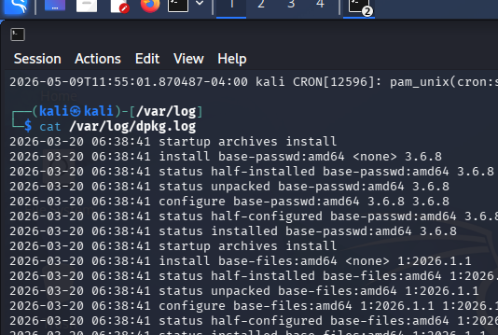
5.Authentication Log Analysis
Command - sudo cat /var/log/auth.log
Open a security activity record and display all authentication events.
The log provides detailed records of:
- User authentication
- SSH login activity
- sudo usage
- Failed login attempts
- Root access attempts

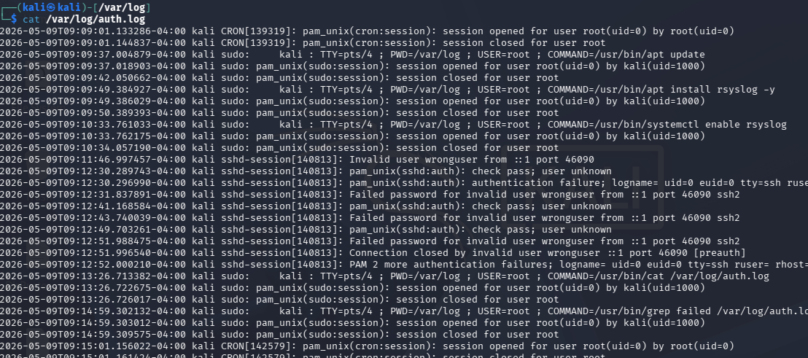

6. journalctl Investigation
Command - sudo journalctl | grep "failed"
journalctl is used to analyzed and identify failed operations/attempts , service issues, and abnormal behavior., it is a important source of system-wide operational and security information.
- Sudo - | Runs the command with administrator privileges

- Journalctl - | Displays system journal logs

- grep "failed" - | Searches for lines containing the word failed
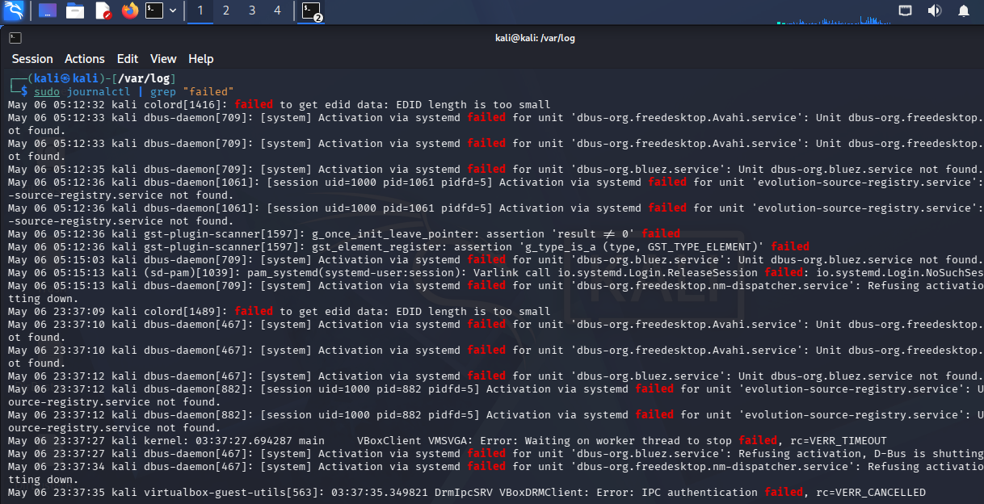

7. SSH Service Verification
The SSH service was started and checked to confirm that remote access was working properly on the Linux system.
SSH secure shell works like secure remote control for a computer. For eg physically sitting in front of a machine, administrators can log remotely and manage the system.this will check machine is active (running) or not .
Command | Purpose
sudo systemctl start ssh : | Starts the SSH service
sudo systemctl status ssh : | Checks whether the SSH service is running
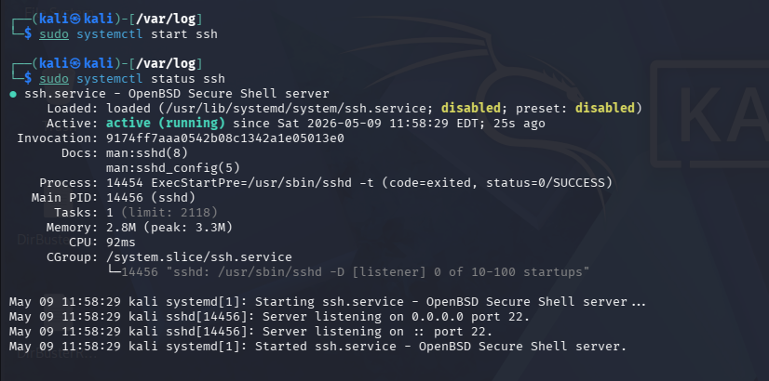

8. rsyslog Verification
rsyslog is a Linux logging service that collects and store system activity logs.
The records information from Applications , Services. The logging service was check to ensure system logs is properly recorded.
Command | Purpose
sudo apt install rsyslog -y | Help to Install a logging service
sudo systemctl enable rsyslog | the service at system starts

- rsyslog already installed :
- rsyslog enabled :


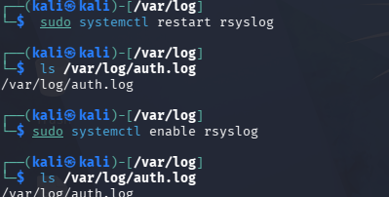

9. Failed Login Attempts
Command - ssh wronguser@localhost
To create unwanted activity for security analysis, failed SSH login attempts were performed on a Linux system.
it is one of a brute force attack (brute force attack – it is a repeated guess the password used to gain unauthorized system access until they found a password .)
- Ssh : | Starts a secure remote login connection
- Wronguser : | Invalid username used for testing
- Localhost : | Refers to the same local machine

Output shows as
1. Permission denied, please try again -The password entered was incorrect.
2. Permission denied (publickey,password) - All authentication methods are failed.

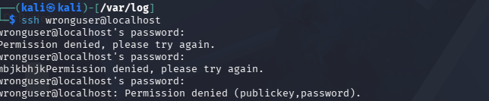
10. Evidence Found in auth.log
after performing the failed login attempts, the authentication log was checked again and identify malicious activity is recorded by system.
Important Log Entries
Invalid User Detection
- Invalid user wronguser from ::1 port 46090
Authentication Failure
- pam_unix(sshd:auth): authentication failure
Failed Password Attempts
- Failed password for invalid user wronguser
Multiple Authentication Failures
- PAM 2 more authentication failures
Connection Closed Events
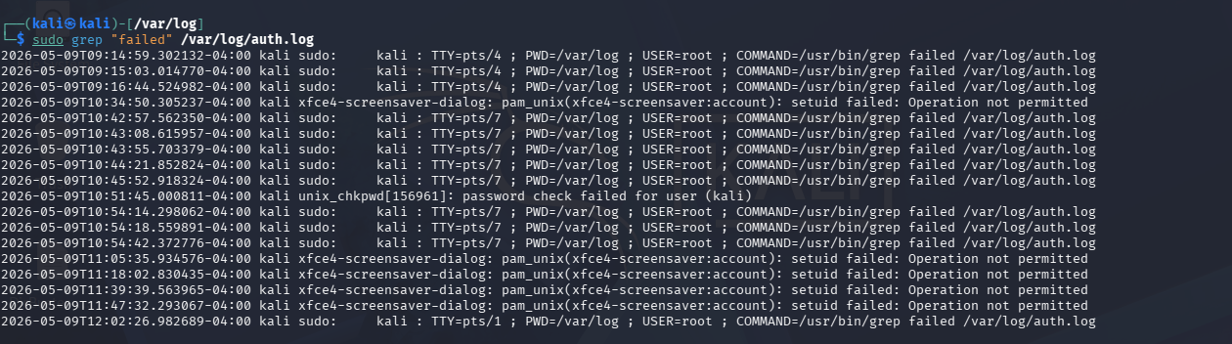

11.Failed Authentication Event Count
Command - sudo grep "failed" /var/log/auth.log | wc -l
This command is used to count how many times the word "failed" appears inside the authentication log file.
It is helps to security teams quickly identify the number of failure related events recorded in the system logs.


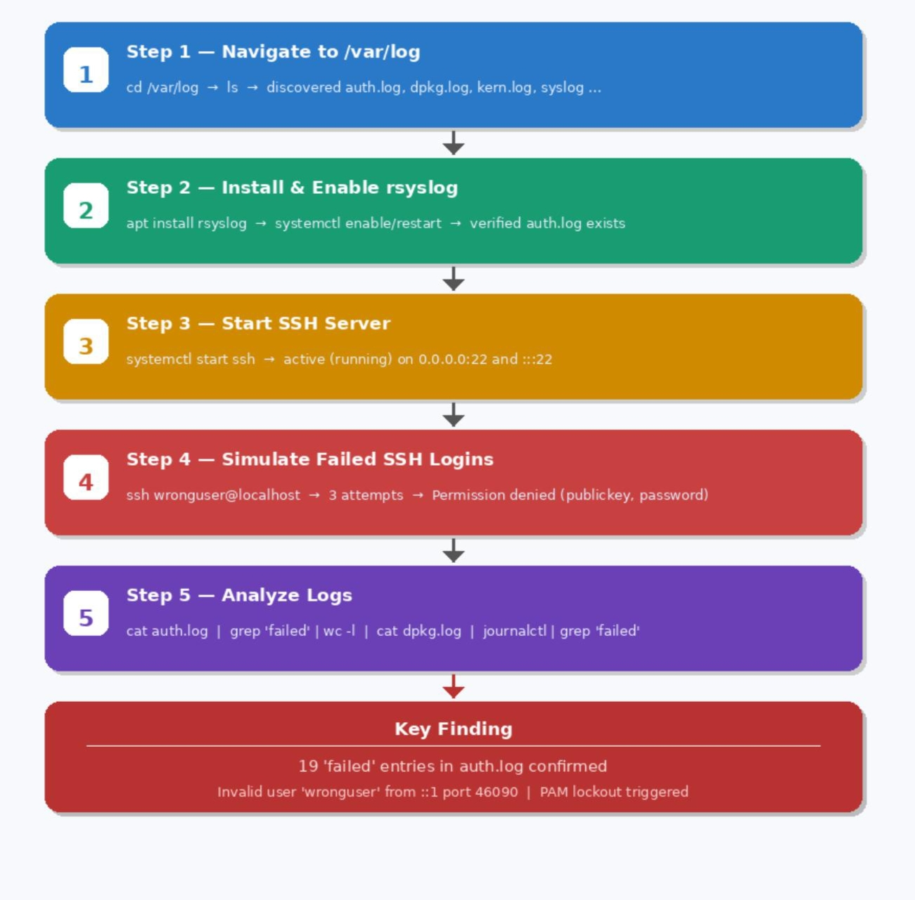

CONCLUSION :
This project helps to understand how to analyze a Linux log files to find failed login attempts and malicious activities. We used different commands and log files such as auth.log, journalctl, and SSH to check authentication records and system events .
we learned how system logs help in identifying security problems and monitoring user activities in a system and also gained basic knowledge of Linux log investigation and cybersecurity monitoring.

----------------------------------------------------------------------------------------------------------------

